**TASK 1 REGISTRATION FORM SOURCE CODE:**

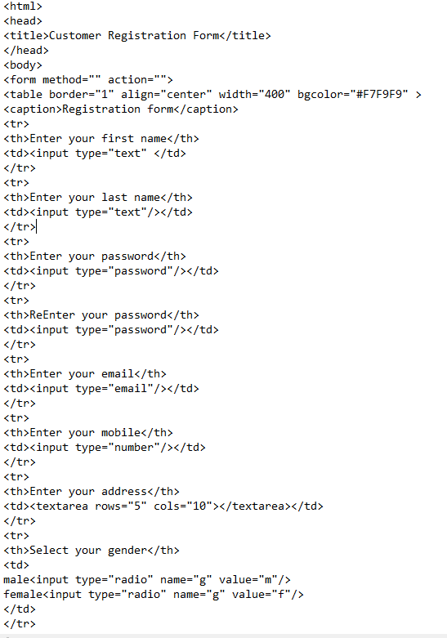

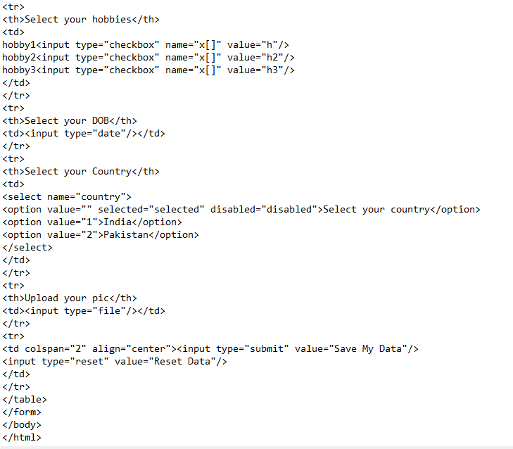

**TASK 1 REGISTRATION FORM OUTPUT:**

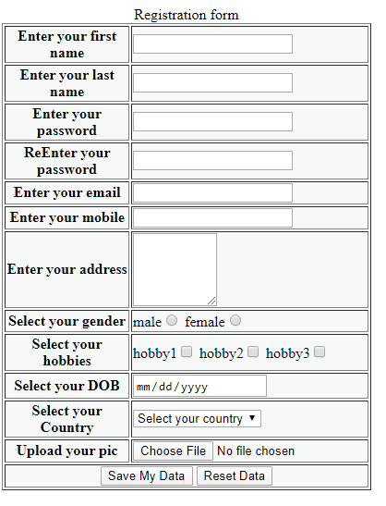

**TASK 2 REGISTRATION FORM SOURCE CODE:**

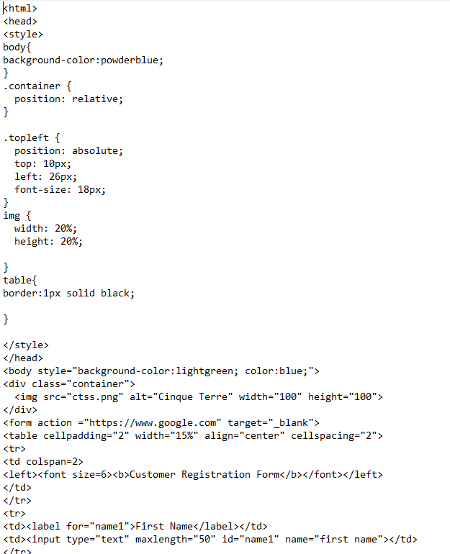

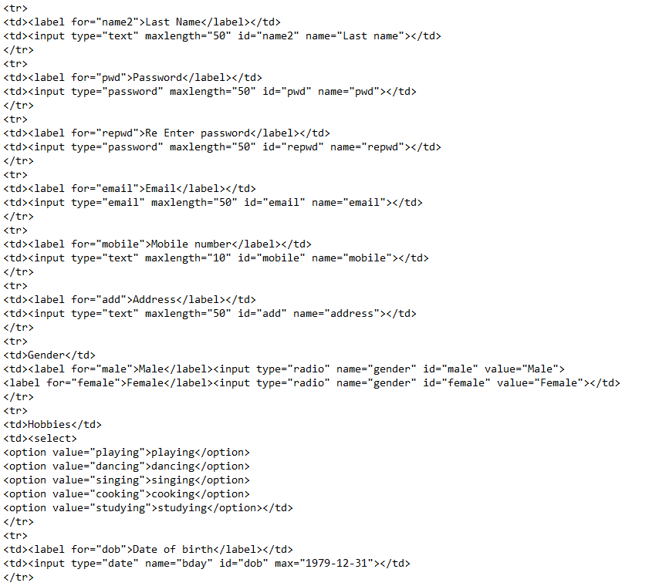

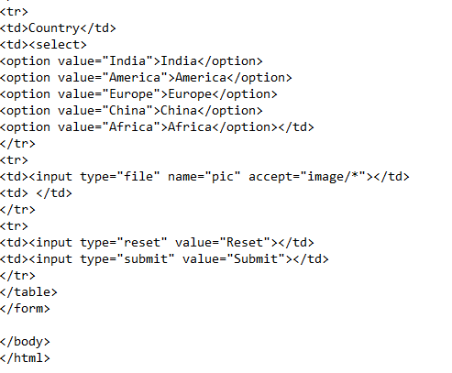

**TASK 2 REGISTRATION FORM OUTPUT:**

